Protein Structure Prediction With Evolutionary Algorithm
Natalio Krasnogor, William E. Hart, Jim Smith and David A. Pelta
Proceedings of the Genetic and Evolutionary Computation Conference, 1999
Abstract
In this paper we consider the design of genetic algorithms that have been applied to a simple protein structure prediction problem.
- Introduction
In this paper we examine the basic design principles that have guided prior work with Gas on the PSP problem for the HP model. Our analysis considers the impact of several algorithmic factors for this problem:
1. The conformational representation
2. The energy formulation
3. The way in which infeasible conformations are penalized
- The HP protein folding model
The free energy of a folding is the number of non-local 1-1 bounds in the folding multiplied by some constant ε < 0. (The value of ε is typically taken to be –1.) The free function models that belief that the driving force of protein structure formation is interactions between hydrophobic amino acid.
Ex: The conformation in Figure 1a has an energy of –4 and the conformation in Figure 1b has an energy of –6.

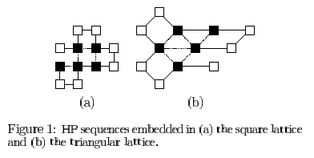
- PSP methods for the HP model
The PSP problem for the HP model has been shown to be NP-complete on the square lattice and cubic lattice.
The embedding of a sequence in a lattice may be represented in a number of ways. Three common methods are Cartesian coordinates, internal coordinates, and as a distance matrix.
Internal coordinates
- absolute direction: {U,D,L,R,F,B}^{n-1}
- relative offsets: {F,L,R,U,D}^{n-2}
- Algorithmic design
4.1 Encoding for internal coordinates
Ex: Consider the effect of one-point mutation on the structure in Figure 2(a). It’s relative coding is S_{rel} = FLLFRRLRLLR. A one point mutation in the 6th position could produce either of S_{rel}¹=FLLFRFLRLLR or S_{rel}²=FLLFRLLRLLR. In absolute encoding, Figure 2(a) is encode as S_{abs}=RULLURURULU while Figure 2(b) is S_{abs}¹=RULLUULULDL and Figure 2(c) is S_{abs}²=RULLULDLDRU.
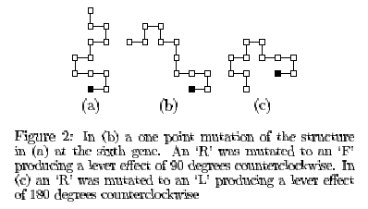
4.2 Potential energy formulation
In the Figure 3 show that 3(a) is closer to forming the optimal conformation than 3(b).
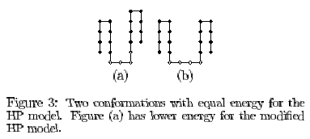
let d_{ij} is the distance between two hydrophobic amino acids Hi and Hj,
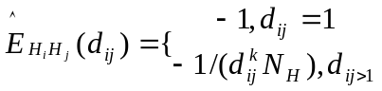
where N_{H} equals the number of hydrophobics in the polymer sequence, where k=4 for the square lattice and k=5 for the triangular and cubic lattices.
4.3 Constraint management
Two broad classes of constrains need to be enforced to define a feasible conformation: (1) the connectivity of the polymer chain and (2) the self-avoidance of the conformation.
Two basic approaches have been taken to manage self-avoiding constrains when internal coordinates are used.
  - the search is constrained to only consider feasible, self-avoiding conformation
  - enforcing constraints uses penalties to guide the GA toward feasible solutions.
->a penalty is added for every pair of amino acids that lie at the same lattice point. O(n²)
->a penalty is added for every lattice point at which there are two or more amino acids. O(n)
- Methods and results
Relative V.S Absolute encoding
- the relative was almost always better than the absolute encoding for the square and cubic lattices
- the robustness of the relative encoding degrades when we look to the triangular lattice
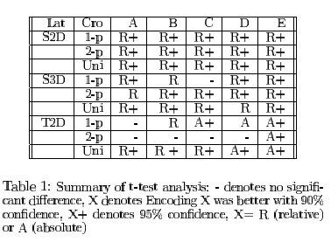
Standard V.S Distance energy
The result of the experiments do not show a substantial impact.
Created by : Yi-Yin Chen
Date : Sept. 25, 2001

